Software Architecture and Design Specification
  - Restaurant Management System

Document Information | Details
Document Type | Software Architecture and Design Specification
System | Restaurant Management System RMS
Version | 1.0
Status | Design baseline for mini project implementation
Prepared for | Software Engineering Mini Project
Date | 01 October 2026

Purpose
This specification defines a practical, secure, and implementable design for a single-outlet restaurant system that manages table bookings, menu items, orders, and live order tracking.

Document Control
Version | Date | Author | Change Summary
1.0 | 01 Oct 2026 | Project Team | Initial architecture and design specification

Approval Record
Role | Name | Approval Status | Date
Faculty Evaluator | To be completed | Pending | To be completed
Project Team Representative | To be completed | Pending | To be completed

Table of Contents
Section | Title
1 | Introduction
2 | Architecture Overview
3 | Component Architecture
4 | Security Architecture
5 | Detailed Design
6 | Data Design
7 | API and Interface Design
8 | Error Handling and Validation
9 | Deployment and Quality Attributes
10 | Requirements Traceability and Verification
Appendix A | Glossary and Assumptions
Appendix B | Representative API Payloads

List of Figures
Figure | Title
1 | Restaurant Management System Component Architecture
2 | Logical Data Model
3 | Sequence Diagram Table Booking
4 | Sequence Diagram Food Ordering and Live Tracking
5 | Sequence Diagram Authentication and Authorization
6 | Order Lifecycle and Allowed Transitions
7 | Deployment View for a Single Restaurant Outlet

1 Introduction

1.1 Purpose
This Software Architecture and Design Specification SAD translates the approved Software Requirements Specification SRS for the Restaurant Management System RMS into an implementable solution. It defines the system structure, component responsibilities, data model, interfaces, security controls, failure behavior, and requirement traceability needed by the development team and evaluator.

1.2 Scope
RMS is a web application for one restaurant outlet. Customers can check table availability, reserve or cancel a table, browse available menu items, place an order, and follow its status. Staff can view and manage bookings and update orders. Admins can manage the menu and staff-facing operations. This version does not include payment-gateway integration, multiple branches, email, or SMS notifications.

1.3 Intended Readers
Reader | How this document is used
Developers | Implement the system consistently and make design decisions without redefining the approved requirements.
Faculty evaluators | Review architectural completeness, real-world feasibility, and traceability.
Restaurant staff and admin | Validate that daily booking, menu, and order operations are supported.

1.4 Design Objectives
- Prevent duplicate bookings even when two customers submit requests at nearly the same time.
- Ensure an order cannot be placed for an item that becomes unavailable after it was added to the cart.
- Persist the authoritative business state before a customer sees a confirmation or live update.
- Give each role only the permissions required for daily work.
- Keep the design simple enough to implement within a mini-project timeline while retaining clear extension points.

1.5 References
ID | Reference
R1 | Software Requirements Specification Restaurant Management System Version 1.0, 06 September 2026.
R2 | Test Plan Document Restaurant Management System, supplied project baseline.
R3 | Software Engineering Mini Project Deliverables Part 1.
R4 | Django and Django REST Framework documentation; Node.js and Socket.io documentation.

2 Architecture Overview

2.1 Architectural Pattern
RMS uses a layered web-application architecture with a separate real-time notification service. The presentation layer contains the customer and staff/admin web interfaces. Django REST Framework hosts the application layer, where authentication, validation, business rules, and database transactions are enforced. PostgreSQL is the system of record. A Node.js Socket.io service delivers persisted order-status changes to connected clients over authenticated WebSocket connections.
Layer | Primary Responsibility | Why It Is Needed
Presentation | Render responsive pages, collect input, show validation messages and real-time status. | Customers and restaurant staff need simple workflows on browser-based devices.
Application | Apply business rules, role checks, API validation and transactions. | Business decisions remain server-side and cannot be bypassed by changing the UI.
Real-time communication | Deliver only authorized order-status events. | A long-lived WebSocket avoids page refreshes and supports REQ-10.
Persistence | Store durable operational records and constraints. | Confirmed bookings and orders must survive server restarts.

2.2 Architecture Decisions
Decision | Rationale | Operational Consequence
Django REST Framework is the business API | Matches the SRS technology constraint and provides mature authentication, serializers, ORM, and security protections. | All state-changing REST requests pass through Django validation and transactions.
Node.js is limited to real-time delivery | Node.js is required by the SRS for WebSocket updates, but should not become a second owner of business rules. | Django persists status first and then publishes an internal event to Node.js.
PostgreSQL is preferred for production or demo | It supports transactions, constraints, row locking, and reliable concurrent access. SQLite remains acceptable only for a low-concurrency demonstration. | Database operations become the final protection against double booking.
Server derives availability from booking intervals | A permanent table Reserved flag cannot represent different time slots accurately. | A table may be available at 18:00 and booked at 19:00 on the same date.

2.3 Main Runtime Flow
A browser uses HTTPS REST requests for all reads and changes. The order-status tracking page also establishes a secure WebSocket connection. When staff update an order, Django validates the allowed transition, commits it to the database, and then sends an internal event to Node.js. Node.js publishes the event only to the authenticated room for that order. If an event is missed, the browser retrieves the current status from the REST API; the database remains authoritative.

3 Component Architecture
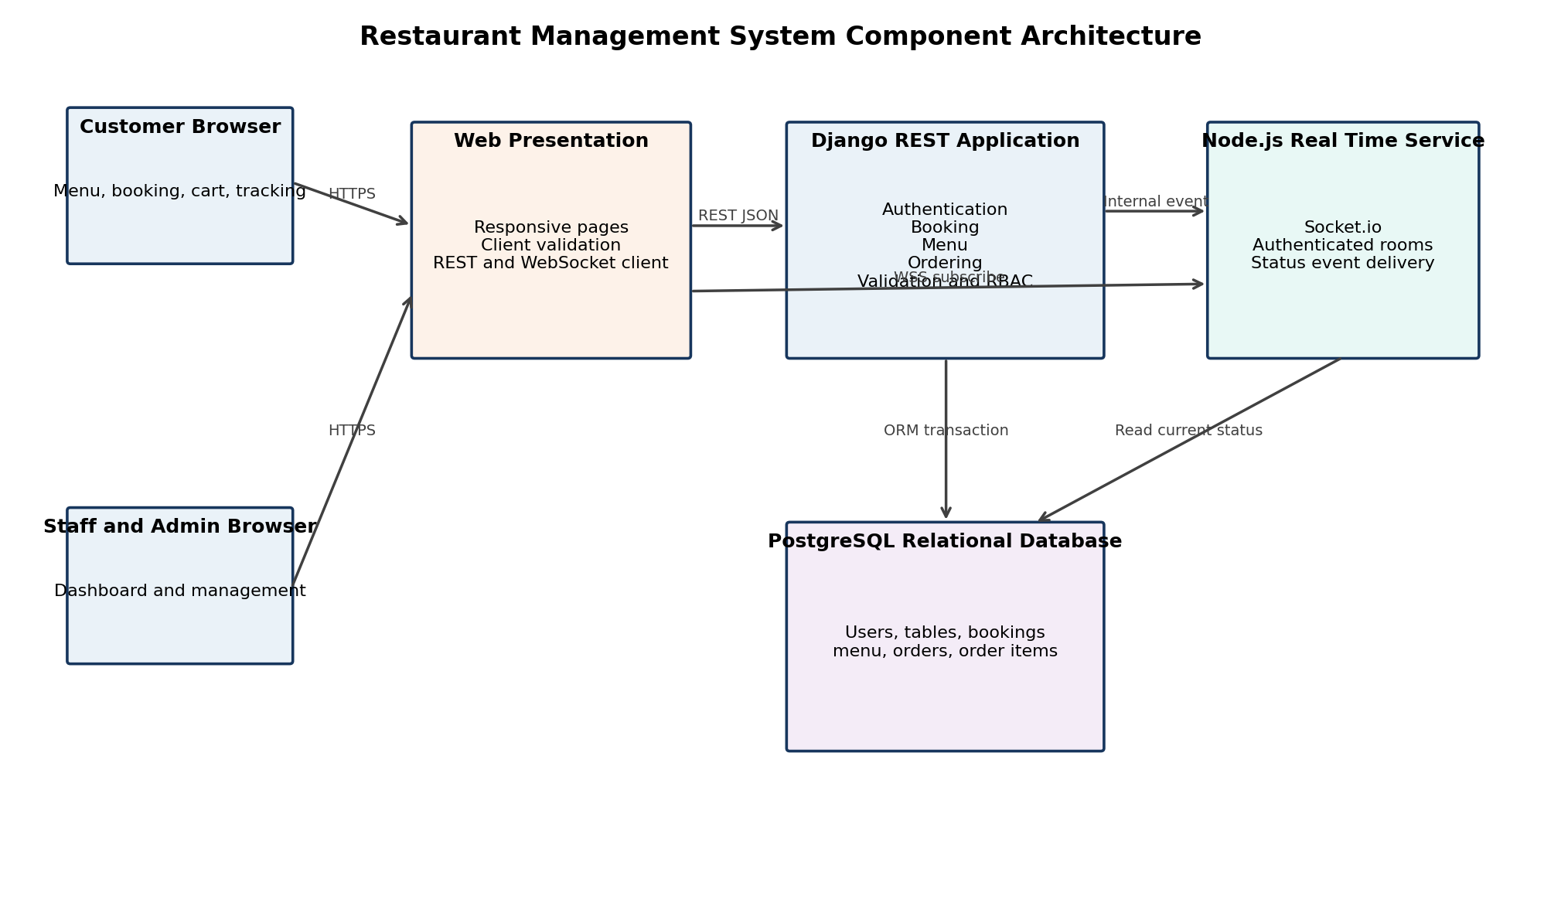
Figure 1. Restaurant Management System Component Architecture

3.1 Component Responsibilities
Component | Responsibilities | Provided Interfaces | Dependencies | Requirements
Customer Web UI | Browse menu, booking form, cart, tracking page, display messages. | HTTPS pages; REST client; WSS client. | Django API; Node.js service. | REQ-1, 2, 3, 6, 7, 8, 10, 11, 12
Staff and Admin UI | Booking search and override, order updates, menu management. | Protected HTTPS pages and REST client. | Django API. | REQ-4, 5, 9, 13
Django Authentication Module | Registration, password verification, sessions/tokens, role enforcement. | /api/auth/*; permission checks. | User records; password hasher. | REQ-12, 13, 14
Django Booking Module | Availability search, create/cancel bookings, booking reference, staff management. | /api/tables/availability; /api/bookings. | Tables, bookings, users; DB transaction. | REQ-1 to REQ-4
Django Menu Module | Admin CRUD, customer listing of available items by category. | /api/menu endpoints. | Menu items; RBAC. | REQ-5 to REQ-7
Django Ordering Module | Validate cart, calculate total, create order/items, enforce status transition. | /api/orders endpoints. | Menu, orders, users; event publisher. | REQ-8, 9, 11
Node.js Real Time Service | Authenticate WebSocket connection; subscribe customer to own order room; emit status changes. | WSS Socket.io events. | Django internal event; current order status. | REQ-10
PostgreSQL Database | Store durable data; enforce keys, checks and transaction isolation. | Relational data service. | Django ORM; restricted Node.js read access. | All data-related requirements

3.2 Component Interaction Rules
- Only Django owns booking, menu, order, authentication, and authorization decisions. The Node.js service never writes business data directly.
- Django sends a real-time event only after the order update transaction commits successfully. This prevents a customer from seeing a state that was not saved.
- Node.js authorizes an order subscription by verifying the user identity and confirming that the customer owns the order or is authorized staff/admin.
- Both customer and staff views use REST as the recovery path after reconnecting, refreshing, or receiving an out-of-order event.

4 Security Architecture

4.1 Security Objectives
Objective | Design Response
Confidentiality | Use HTTPS and WSS; do not expose password hashes, internal database identifiers, or another customer’s booking/order data.
Integrity | Validate all state changes server-side; use transactions; enforce allowed status transitions; record audit fields such as created_at, updated_at, and actor ID.
Availability | Return clear retry-safe errors, retain authoritative state in PostgreSQL, and let clients recover status through REST after WebSocket interruption.
Account protection | Use Django-supported salted password hashers, rate-limit login attempts, expire inactive sessions, and avoid detailed login-error disclosures.

4.2 Authentication and Session Management
The system uses Django authentication with an email or phone number and a password. Passwords are never stored or logged in plain text. On successful login, the server issues a secure session or signed token with a configured inactivity timeout of 30 minutes for this project. Each protected request revalidates the identity and role. A logout or inactivity expiration invalidates the session/token and returns 401 Unauthorized for further protected requests.

4.3 Authorization Matrix
Operation | Customer | Staff | Admin
Browse available menu | Allowed | Allowed | Allowed
Create own booking | Allowed | Allowed on behalf of customer | Allowed on behalf of customer
View bookings | Own bookings only | All current bookings | All bookings
Cancel booking | Own booking if at least 30 min remain | Manual cancel with reason | Manual cancel with reason
Create or edit menu item | Denied | Denied | Allowed
Place order / view own order | Allowed | May place on behalf of customer | Allowed
Update order status | Denied | Allowed | Allowed
Manage staff accounts | Denied | Denied | Allowed

4.4 Security Controls by Boundary
Boundary | Control
Browser to Django | HTTPS, CSRF protection for cookie sessions, CORS allowlist, server-side request validation, response fields limited by role.
Browser to Node.js | WSS, access credential at connection, per-order room authorization, reconnect requires re-authentication.
Django to PostgreSQL | ORM parameterization, least-privilege database account, transactional writes, backups for demo data.
Django to Node.js | Internal authenticated endpoint or signed event payload; Node.js accepts events only from the application service.
Admin actions | Role check, validation, audit fields, and user-visible error without exposing internal exception details.

4.5 Practical Threat Handling
Threat | Mitigation
SQL injection | Use Django ORM and parameterized queries; reject unvalidated filters; no string-built SQL.
Cross-site scripting | Escape template output, validate input, apply Django security middleware, avoid rendering raw user input.
Privilege escalation | Enforce permissions in every API view; hide buttons only as a usability feature, not as security.
Double booking race | Perform overlap check and booking creation inside one transaction with table-row locking or serializable protection.
Stale cart manipulation | Re-read each item availability and current price at checkout; calculate total on server.
Event disclosure | Authorize room subscription against the requesting user and order ownership before emitting status.

5 Detailed Software Design

5.1 Booking Design
A booking request includes date, start time, party size, and selected table. The server derives end time from the restaurant turnaround period, configured as 90 minutes in the initial release. The Booking module checks table capacity, locks the target table row, rechecks overlapping confirmed bookings, creates a confirmed booking, and generates a human-readable reference such as BK-1001. The database transaction commits before confirmation is returned. A cancellation is allowed only when server time is at least 30 minutes before the reservation start; it changes the booking status to Cancelled rather than deleting the record.
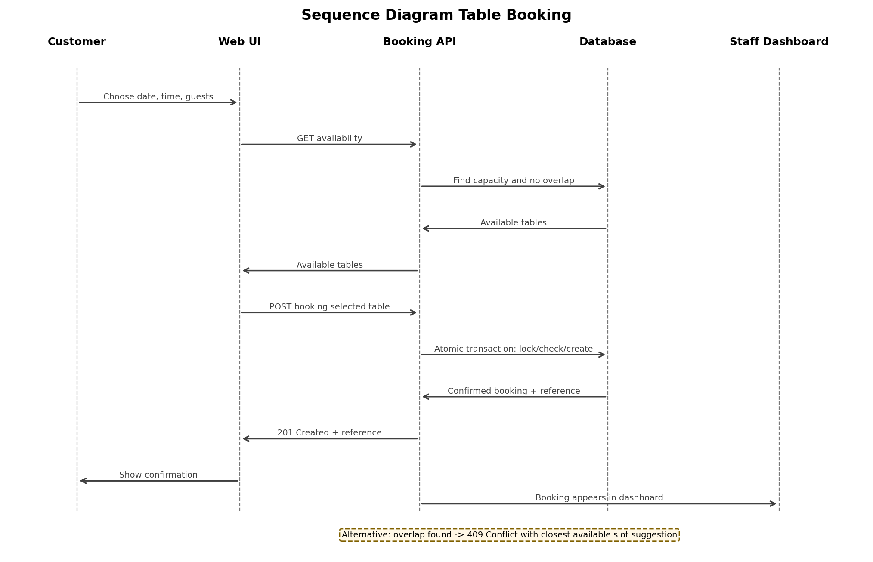
Figure 2. Sequence Diagram Table Booking

5.2 Food Ordering and Real Time Tracking
The cart exists in the browser until checkout. At checkout, the Ordering module treats the submitted items as untrusted: it loads every menu item again, checks that each is available, validates quantity, snapshots each accepted unit price into OrderItem, calculates the total on the server, and writes the order and items atomically. The initial status is Received. Staff may transition Received to Preparing and Preparing to Served. A cancelled transition is reserved for an approved exception before preparation and must record a reason.
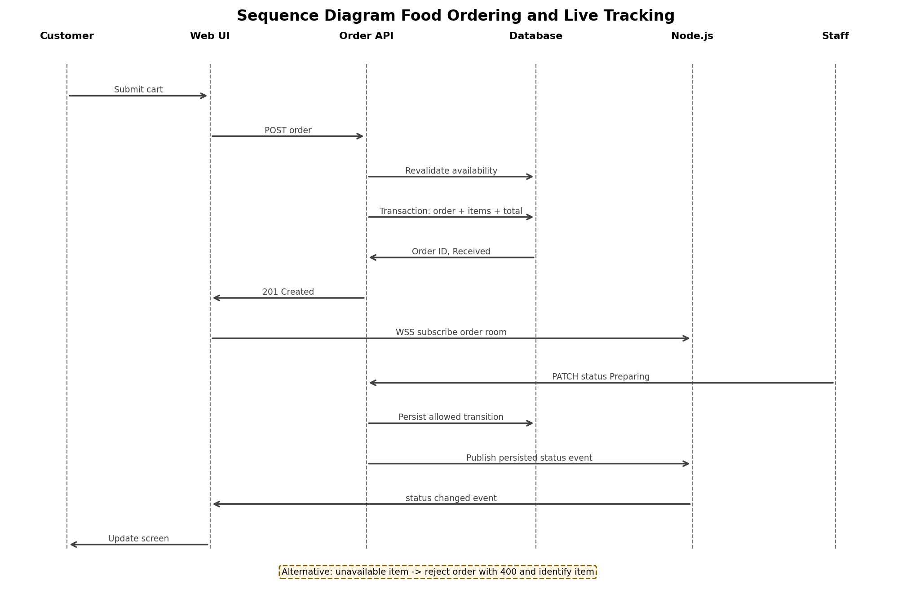
Figure 3. Sequence Diagram Food Ordering and Live Tracking

5 Detailed Software Design Continued

5.3 Authentication and Authorization
Registration checks uniqueness of email/phone and password policy. Login uses Django password verification, not a direct database comparison. Protected endpoints enforce authentication first and authorization second. The API uses 401 when the user has no valid authentication and 403 when the authenticated role lacks permission. These distinctions make errors actionable while avoiding disclosure of account existence.
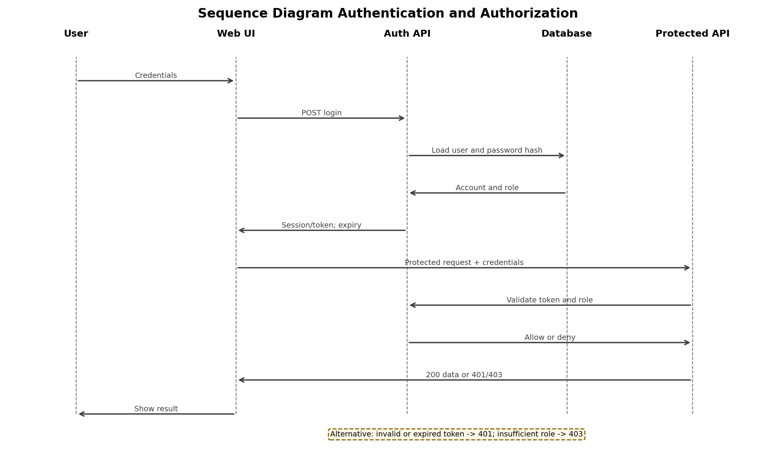
Figure 4. Sequence Diagram Authentication and Authorization

5.4 Order State Model
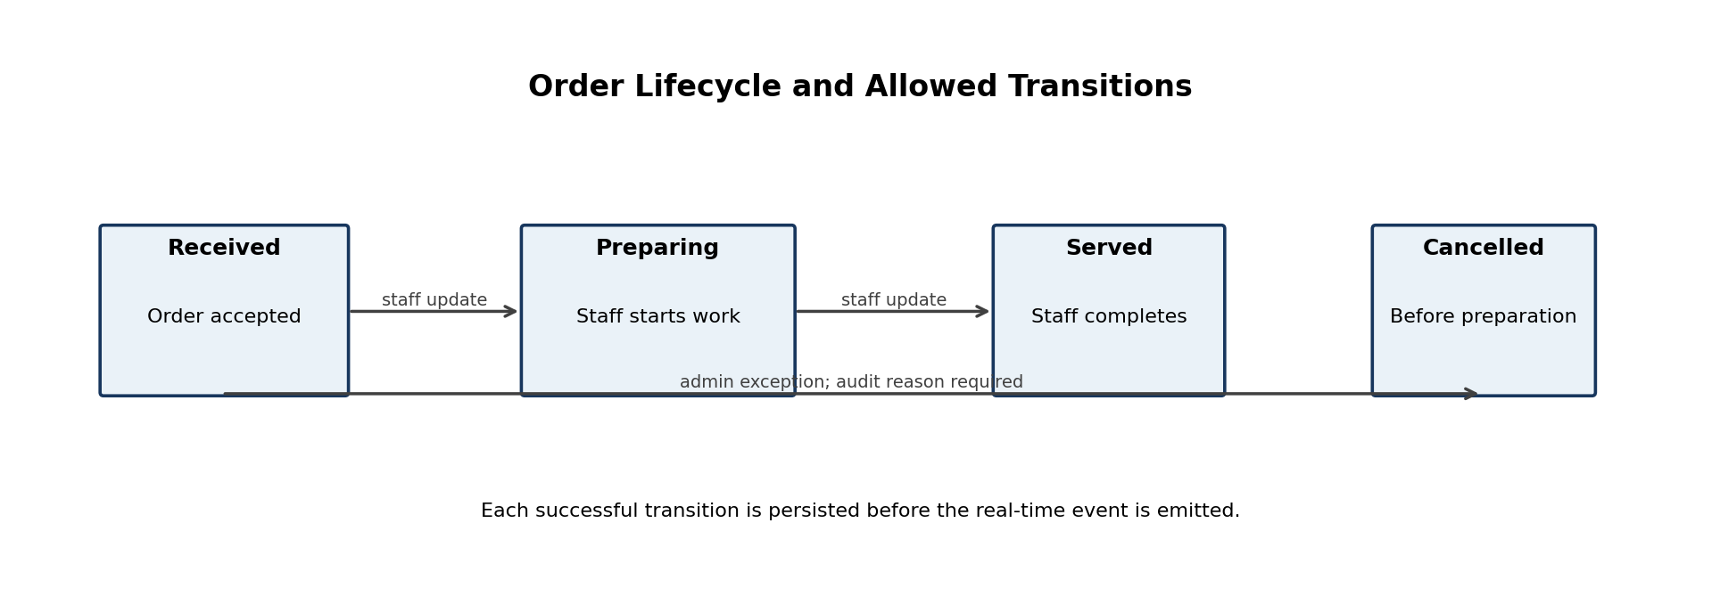
Figure 5. Order Lifecycle and Allowed Transitions

5.5 Idempotency and Recovery
Situation | Design Behavior
Customer resubmits booking after network uncertainty | The client supplies an idempotency key. Django returns the original confirmed booking for a repeated key instead of creating a duplicate.
Customer loses connection after placing order | The order is still committed if the server responded internally. On return, the customer uses GET /api/orders/{id} or the order history to retrieve the authoritative state.
WebSocket disconnects | Client reconnects with valid authentication, re-subscribes to its order room, and requests current order status using REST.
Staff double-clicks status update | The API validates the current state; a repeated update to the same state is treated as a no-op or returns the current state, never creates a duplicate event.

6 Data Design
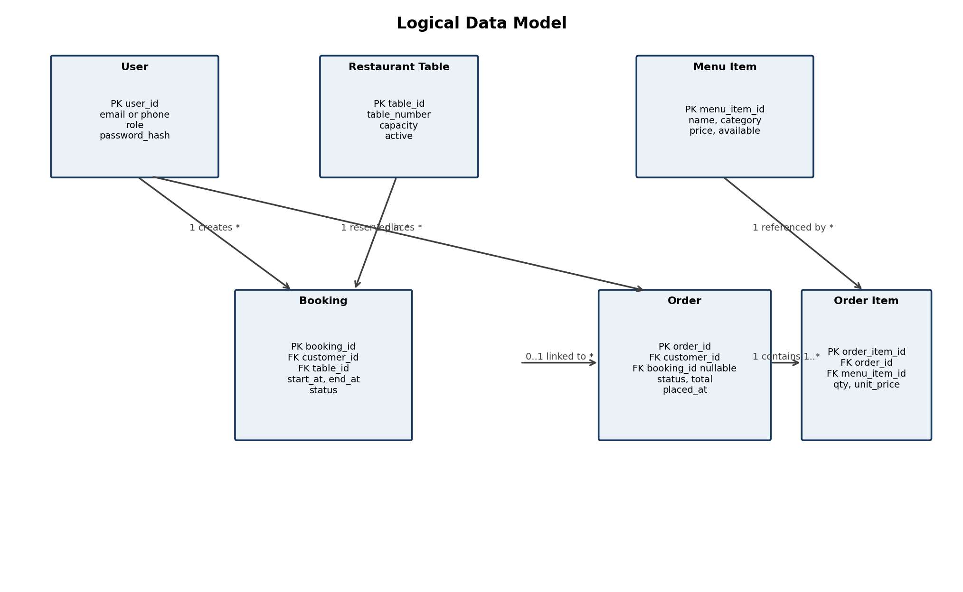
Figure 6. Logical Data Model

6.1 Core Tables and Constraints
Table | Key Fields | Important Constraints
User | user_id, email, phone, role, password_hash | Unique non-null login identifier; role in Customer, Staff, Admin; password_hash never returned by API.
RestaurantTable | table_id, table_number, capacity, active | Unique table_number; capacity greater than zero; inactive table cannot accept new booking.
Booking | booking_id, customer_id, table_id, start_at, end_at, status | start_at before end_at; party size greater than zero; Cancelled records retained; overlap prevention enforced in transaction.
MenuItem | menu_item_id, name, category, price, available | Price non-negative; category required; unavailable items excluded from customer listing.
Order | order_id, customer_id, booking_id, status, total_amount, placed_at | Status constrained to valid lifecycle; total non-negative; booking reference optional.
OrderItem | order_item_id, order_id, menu_item_id, quantity, unit_price | Quantity greater than zero; unit_price non-negative; unit_price is a snapshot at checkout.

6.2 Double Booking Prevention
Availability shown to the user is advisory because another customer can act at the same time. The decisive check happens during booking creation. Django begins a transaction, locks the selected table row, checks whether a non-cancelled booking exists for the same table where existing.start_at is before requested.end_at and existing.end_at is after requested.start_at, and creates the booking only when no overlap exists. If an overlap is found, the transaction is rolled back and the API returns 409 Conflict with alternative slots. For PostgreSQL, an exclusion constraint on the table/time range is a strong additional safeguard; for the mini-project, transaction plus row lock is the minimum implementation standard.

6.3 Data Retention and Audit Fields
Bookings and orders are not hard-deleted during normal operations. Each retains created_at, updated_at, and the acting user where relevant. Menu items referenced by open or historical orders should be marked unavailable rather than deleted; a hard delete is allowed only when the item has no order references. This preserves report accuracy and prevents a past order from losing its item name or price.

7 API and Interface Design

7.1 REST API Conventions
All REST endpoints use JSON over HTTPS and the /api prefix. Protected endpoints require a valid session/token. The server validates inputs, uses consistent HTTP status codes, and returns an error object with code, message, and optional field details. IDs in examples are illustrative and not a claim of existing implementation.
Method | Endpoint | Authorization | Purpose
POST | /api/auth/register | Public | Create a customer account.
POST | /api/auth/login | Public | Authenticate and issue session/token.
POST | /api/auth/logout | Authenticated | Invalidate active session/token.
GET | /api/tables/availability | Public or authenticated | Return tables that fit requested date, time, and guests.
POST | /api/bookings | Customer or staff/admin | Create a reservation using atomic availability validation.
GET | /api/bookings | Authenticated | Customer gets own records; staff/admin get permitted records with filters.
PATCH | /api/bookings/{id}/cancel | Owner or staff/admin | Cancel according to time and role rules.
GET | /api/menu | Public | Return available menu items grouped by category.
POST | /api/menu | Admin | Create menu item.
PATCH | /api/menu/{id} | Admin | Update menu item or availability.
DELETE | /api/menu/{id} | Admin | Delete only when referential rules permit.
POST | /api/orders | Customer or staff/admin | Validate cart and create an order.
GET | /api/orders/{id} | Owner or staff/admin | Return authoritative order and items.
PATCH | /api/orders/{id}/status | Staff or admin | Apply an allowed order-status transition.

7.2 WebSocket Events
Event | Direction | Payload | Authorization and Reliability
subscribe_order | Browser to Node.js | order_id; access credential | Node.js verifies identity and ownership/role before joining the room.
order_status_changed | Node.js to Browser | order_id, status, updated_at, version | Sent only after Django persistence; client compares version and may fetch current REST state.
error | Node.js to Browser | code, message | Does not expose internal details; client retries only when appropriate.

7.3 User Interface Rules
- Booking form shows date, time, party size, available table options, final confirmation reference, and cancellation rule.
- Customer menu hides unavailable items and groups remaining items by category.
- Checkout clearly identifies items rejected after revalidation and preserves the rest of the cart for correction.
- Staff dashboard separates bookings, current orders, and admin-only menu management so role boundaries are visible.
- Every form displays validation messages next to the relevant field and retains non-sensitive entered values where safe.

8 Error Handling and Validation

8.1 Standard Error Response
Field | Meaning
code | Stable machine-readable error identifier, for example TABLE_UNAVAILABLE.
message | Short, user-safe explanation.
details | Optional map of field-specific validation messages or suggested alternate slots.
request_id | Optional server correlation ID for staff debugging; never includes secrets.

8.2 Error Catalog
Scenario | HTTP or Event Result | User-Facing Behavior | Server Action
Invalid or missing input | 400 Bad Request | Highlight invalid field and explain correction. | Reject request before any write.
Unauthenticated protected request | 401 Unauthorized | Ask the user to sign in again. | Do not reveal protected data.
Authenticated but unauthorized | 403 Forbidden | Show permission message. | Log authorization denial at appropriate level.
Table slot conflict | 409 Conflict | Explain that the table was just booked and suggest closest slot. | Rollback transaction; no booking created.
Duplicate registration identifier | 409 Conflict | State that the identifier is already in use without exposing other account data. | Do not create user.
Unavailable cart item | 400 Bad Request | Name unavailable item and return cart correction data. | Do not create partial order.
Invalid order transition | 409 Conflict | Show current order state and permitted action. | Do not publish real-time event.
Resource not found | 404 Not Found | Show not-found state. | Return no extra internal information.
Unexpected server error | 500 Internal Server Error | Show a safe retry message and request ID. | Log stack trace internally; rollback transaction.
WebSocket interruption | Reconnect event or timeout | Show reconnecting indicator; refresh authoritative status after reconnect. | No business data is changed by reconnect.

8.3 Validation Rules
Input Area | Rules
Booking | Future date/time; positive party size; active table capacity at least party size; no overlap; cancellation at least 30 minutes before start for customer.
Menu item | Required name and category; price zero or greater; availability is boolean.
Order | At least one item; positive integer quantity; all items available at checkout; total calculated only on server.
Account | Unique email or phone; password policy; role is server-controlled and customer registration creates Customer role only.
Order status | Only Received to Preparing to Served in normal flow; exception cancellation must be authorized and audited.

9 Deployment and Quality Attributes
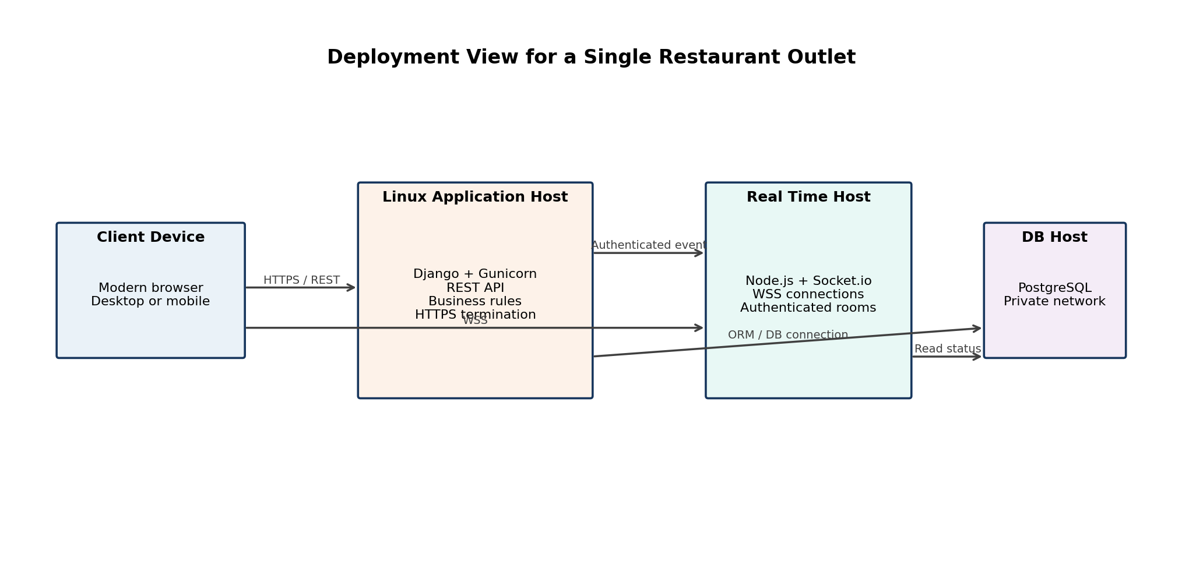
Figure 7. Deployment View for a Single Restaurant Outlet

9.1 Deployment Principles
The recommended demonstration deployment has Django and Node.js as separate processes behind an HTTPS-capable reverse proxy, with PostgreSQL on a private database connection. Environment secrets are stored outside source control. SQLite may be used only for a classroom demonstration with limited concurrent activity; PostgreSQL is the preferred choice when validating the 50-user and booking-concurrency targets.

9.2 Quality Attribute Tactics
Quality Attribute | SRS Target | Design Tactic | Verification Reference
Performance | Page/API response within 2 seconds under normal load | Index booking start time/table, paginate staff lists, avoid N+1 ORM queries, keep WebSocket payload small. | Add NFR performance test set before final submission.
Concurrency | At least 50 concurrent users | Stateless API requests, database transactions, connection pooling, and load test with realistic booking/order mix. | Add NFR concurrent-user test.
Real-time latency | Order status appears within 1 second | Persist then publish compact event; instrument publish and client-receive times. | IT_06 and IT_07, plus timing assertion.
Reliability | Confirmed booking/order data is not lost | Atomic database transactions, durable PostgreSQL storage, retry-safe request IDs, recovery through GET APIs. | IT_01 and IT_08.
Usability | No training for customer flows | Clear labels, inline validation, few-step booking/order flow, status labels. | ST_01, ST_05, and usability walkthrough.
Maintainability | Separate feature modules | Django apps for accounts, booking, menu, orders; documented API and interfaces. | Code review against SAD.
Portability | Latest major browsers | Responsive HTML/CSS; browser smoke tests on Chrome, Firefox, and Edge. | Add browser compatibility test.

9.3 Monitoring for a Real Restaurant
For practical operation, the system should log booking conflicts, order-validation rejections, failed login attempts, status-transition errors, and WebSocket delivery failures with request IDs and timestamps. These records let staff distinguish a genuine booking conflict from a device or connectivity problem. Logs must not contain passwords, tokens, or complete sensitive personal data.

10 Requirements Traceability and Verification
This matrix connects every approved functional requirement to the responsible design area and existing test plan IDs. The design does not claim that these tests have already passed; it defines how the implementation will be verified.
Requirement | Design Element | Primary Verification
REQ-1 | Booking module; availability query; Figure 2; transaction design | UT_01, UT_02, IT_01, ST_01, ST_02
REQ-2 | Booking transaction, row lock, overlap check; Section 6.2 | UT_03, UT_04, IT_01, ST_02
REQ-3 | Cancellation endpoint and time-bound validation | UT_05
REQ-4 | Staff/Admin booking dashboard and protected booking APIs | IT_02, IT_03
REQ-5 | Admin-only menu CRUD; RBAC and menu data rules | UT_06 to UT_09, IT_04, ST_03
REQ-6 | Customer menu availability filter | UT_10, IT_04, IT_05, ST_04
REQ-7 | Category field and grouped menu response/UI | UT_11, ST_03
REQ-8 | Cart revalidation; Order and OrderItem transaction; Figure 3 | UT_12, UT_13, UT_16, IT_08, ST_05
REQ-9 | Order state model; protected status endpoint; Figure 5 | UT_13, UT_14, ST_05
REQ-10 | Django committed event to Node.js; authenticated order room | IT_06, IT_07, ST_05
REQ-11 | Checkout availability revalidation and error response | UT_15, ST_06
REQ-12 | Registration/login; password hasher; Figure 4 | UT_17, UT_18, UT_19, IT_10, ST_07
REQ-13 | RBAC matrix and protected endpoints; Figure 4 | IT_09, IT_10, ST_08
REQ-14 | Inactivity expiry and reauthentication handling | UT_20

10.1 Nonfunctional Verification Gaps to Add Before Final Submission
The supplied test plan has strong functional coverage, but it should be updated with explicit nonfunctional test cases before final submission. These tests strengthen the claim that the project works beyond ideal flows.
Suggested ID | Test Objective | Pass Criterion
NFT_01 | Measure availability, booking, menu, order, and status APIs under normal data volume. | 95 percent of measured responses complete within 2 seconds under normal load.
NFT_02 | Run a load scenario with at least 50 concurrent users doing browse, availability, and order operations. | No data corruption; error rate within accepted project threshold; system remains responsive.
NFT_03 | Measure real-time update delay after staff status change. | Customer receives persisted status event within 1 second in the test environment.
NFT_04 | Attempt two concurrent reservations of the same table/time. | Exactly one booking succeeds; the other receives 409 Conflict.
NFT_05 | Security validation of protected endpoints, expired sessions, and role boundaries. | Unauthorized requests fail with 401 or 403 and reveal no protected data.
NFT_06 | Browser compatibility smoke test. | Core customer and staff workflows work on latest Chrome, Firefox, and Edge.

Appendix A Glossary and Assumptions
Term | Definition
RMS | Restaurant Management System.
Admin | Most privileged role; manages menu and staff-facing operations.
Staff | Restaurant employee who views bookings and updates orders.
Customer | User who books a table and/or places an order.
Booking interval | Reservation start time through computed end time; default turnaround is 90 minutes.
REST API | HTTPS JSON interface exposed by Django REST Framework.
WebSocket | Persistent WSS connection used for server-pushed order-status updates.
RBAC | Role-based access control.

Assumptions
- The project represents a single restaurant outlet and operates in English.
- Table capacity and active status are managed by the restaurant.
- A booking corresponds to one table and the standard turnaround duration is configurable.
- Payment processing is outside Version 1.0 scope.
- The initial implementation may use Django Admin to accelerate trusted admin-side CRUD, but the same authorization and audit rules apply.

Appendix B Representative API Payloads

B.1 Create Booking Request
{
"table_id": 5,
"start_at": "2026-10-15T19:00:00+05:30",
"party_size": 2,
"idempotency_key": "b7e0..."
}

B.2 Successful Booking Response
{
"booking_id": "BK-1001",
"status": "Confirmed",
"start_at": "2026-10-15T19:00:00+05:30",
"end_at": "2026-10-15T20:30:00+05:30"
}

B.3 Table Conflict Response
{
"code": "TABLE_UNAVAILABLE",
"message": "The selected table is no longer available for that time.",
"details": {"suggested_start_at": "2026-10-15T20:30:00+05:30"}
}

B.4 Order Status WebSocket Event
{
"event": "order_status_changed",
"order_id": "OR-2001",
"status": "Preparing",
"updated_at": "2026-10-15T19:18:12+05:30",
"version": 2
}

